1.
- Please name as many different species or kinds of living things in your backyard/neighborhood as you can.

- Imagine you found a living thing that you did not recognize. If you were going to contact an expert to find out what the living thing was, what kinds of things would you tell them so they could figure out what you found? Be as detailed as you can.

- If one kind of living thing in your backyard or neighborhood went extinct, what would happen to the living and non-living things in your backyard or neighborhood? Why?

2. Many forests in the United States have similar, but not identical, insects living in them.
- Why are the insects living in the forest similar but not exactly the same?

- If you took a bunch of different kinds of insects from a forest and put them in an abandoned field about 20 miles away, what do you think would happen? Please explain why. Give as many reasons as you can.

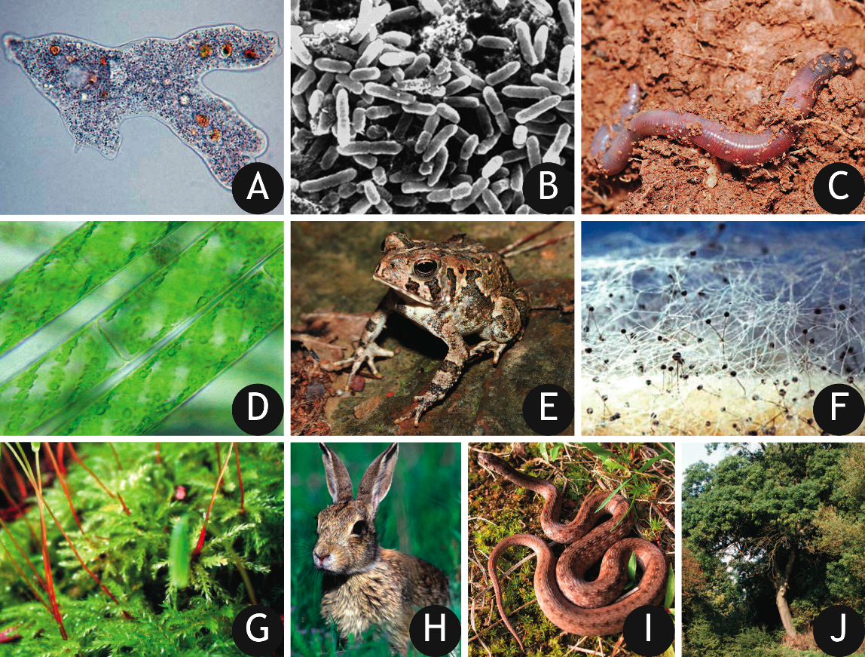
3. Each of these pictures shows a living thing. Can you divide the pictures into groups? (You can make up to five groups, but you don't have to, and a group can be one living thing.) A group can have just one picture, or many, and you should only use each picture once. Write the letters of the pictures you want to group into the spaces below. For each group, explain why you included the pictures you did.

Write the letters for Group 1:
Why did you group these living things together? (Group 1)

Write the letters for Group 2:
Why did you group these living things together? (Group 2)

Write the letters for Group 3:
Why did you group these living things together? (Group 3)

Write the letters for Group 4:
Why did you group these living things together? (Group 4)

Write the letters for Group 5:
Why did you group these living things together? (Group 5)
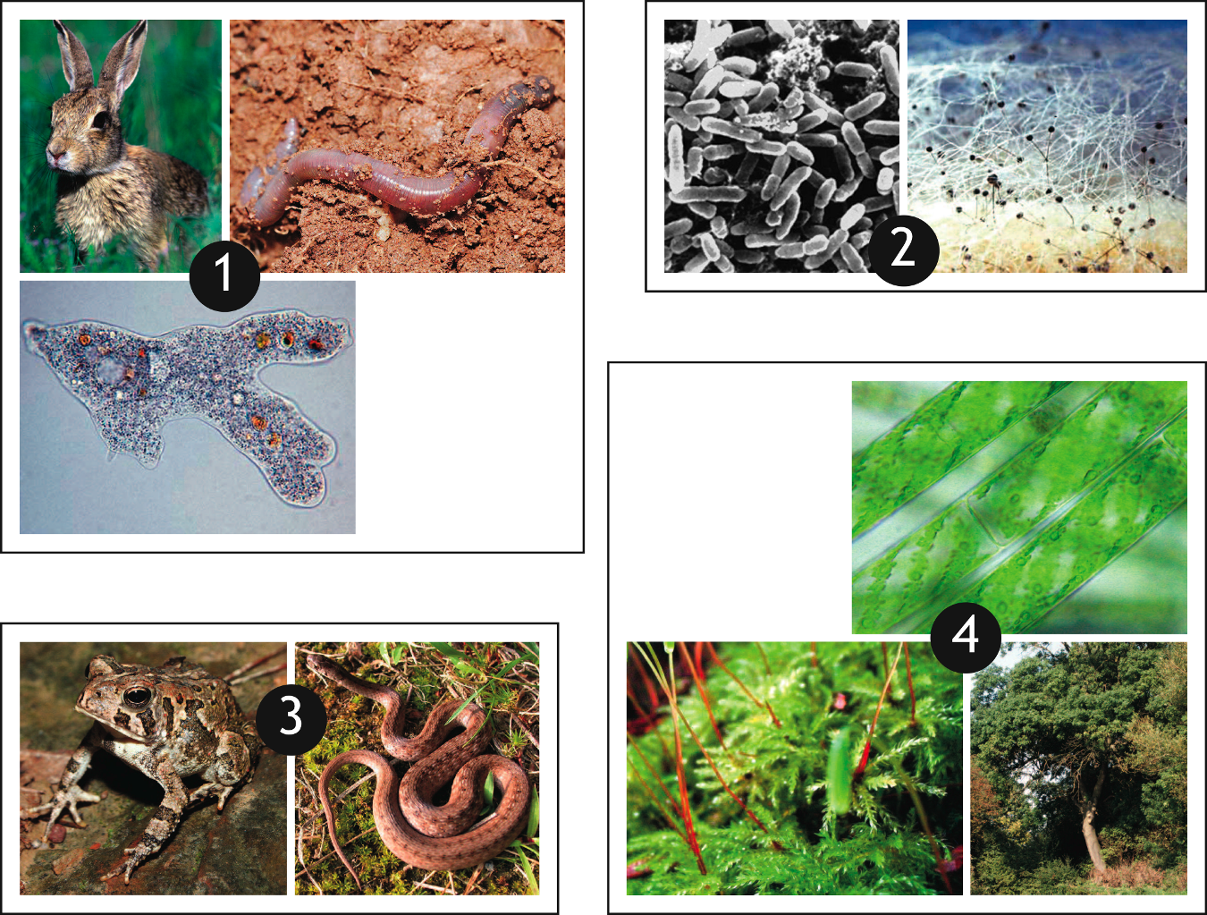

4. The living organisms in these pictures have been arranged into four groups. Can you think of a reason (or reasons) why the living things are grouped the way they are? Be as detailed as you can.

Look at this picture of a new organism. Which group would you add it to? Why?

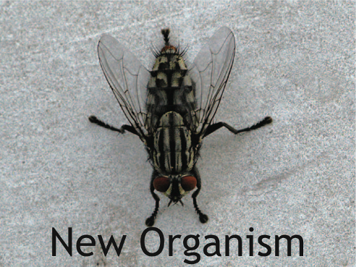

5. A volcano under the ocean erupts and after the lava cools and hardens, a new island is formed. Now the island has almost no living things on it, but over the next 10 years, more and more living things will be found on the island.
- Imagine you work for the U.S. Fish and Wildlife Service and need to make a list of what SPECIFIC living things will be found on the island in 10 years. How would you make the list? Be as detailed as you can in your answer.

- What are some interactions (relationships) with other living things that could affect if an insect can survive and reproduce on the newly formed island? How would that work?

- What are some abiotic (non-living) factors that could affect if an insect could survive and reproduce on the newly formed island? How would that work?

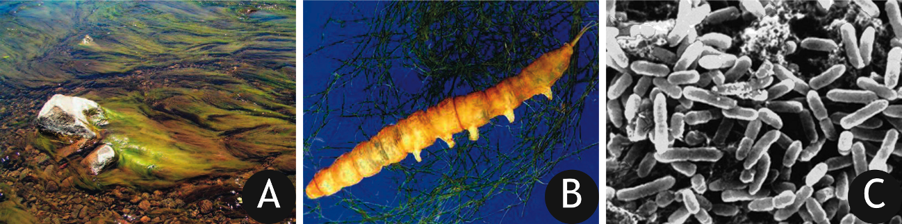
6. Look at the pictures above and decide which one you want to answer questions about. Which one would you pick?
A B C
- What does the living thing you picked eat? How does it get its food?

- What abiotic (non-living) factors does it change as it gets its food?

- What kinds of living things would be affected by the changes you described in Part B?

- In what way would the living things you listed in Part C be affected?

7. As stream usually has several types of insects. Why are there several types of insects in a stream instead of one, best-adapted type of insect?

